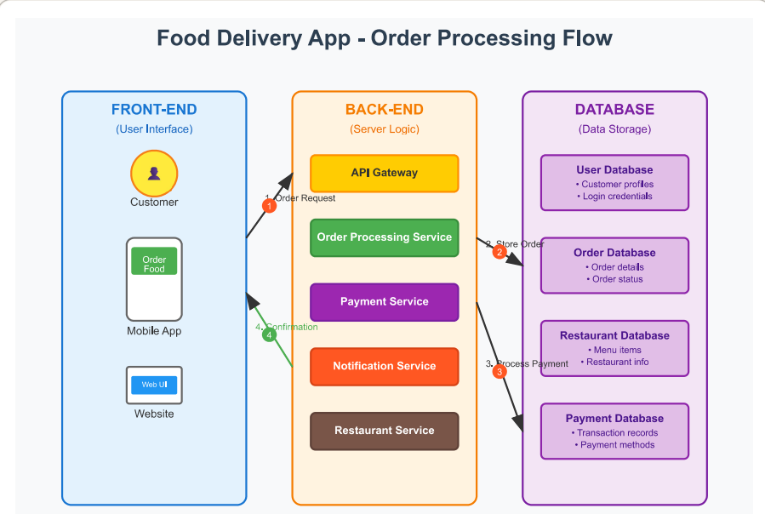

I’ve created a comprehensive food delivery app order processing diagram. The diagram shows the complete flow from customer interaction to order completion.

**\*Key Components:**

\***Front-End (Blue section):**

- Customer interface

- Mobile app and web interface for placing orders

**\*Back-End (Orange section):**

- API Gateway (entry point for all requests)

- Order Processing Service

- Payment Service

- Notification Service

- Restaurant Service

**\*Database (Purple section):**

- User Database (customer profiles, credentials)

- Order Database (order details and status)

- Restaurant Database (menus, restaurant info)

- Payment Database (transactions, payment methods)

**\*Process Flow:**

1. Customer places order through mobile app/website

2. Order details stored in database

3. Payment processed and recorded

4. Confirmation sent back to customer

The diagram uses colour coding and numbered arrows to clearly show how data flows between each layer of the system. This architecture ensures orders are processed efficiently while maintaining data integrity across all components.